NYU-6463 Processor Design

**Functional simulation of ALU:**

1. Test case 1:

Operand 1 : FFFFEEEE

Operand 2 : FFFFEE11

ALU_operation : 0 ALU_output : FFFFDCFF

ALU_operation : 1 ALU_output : 000000DD

ALU_operation : 2 ALU_output : FFFFEE00

ALU_operation : 3 ALU_output : FFFFEEFF

ALU_operation : 4 ALU_output : 00001100

ALU_operation : 5 ALU_output : DDDC0000

ALU_operation : 6 ALU_output : 00000000

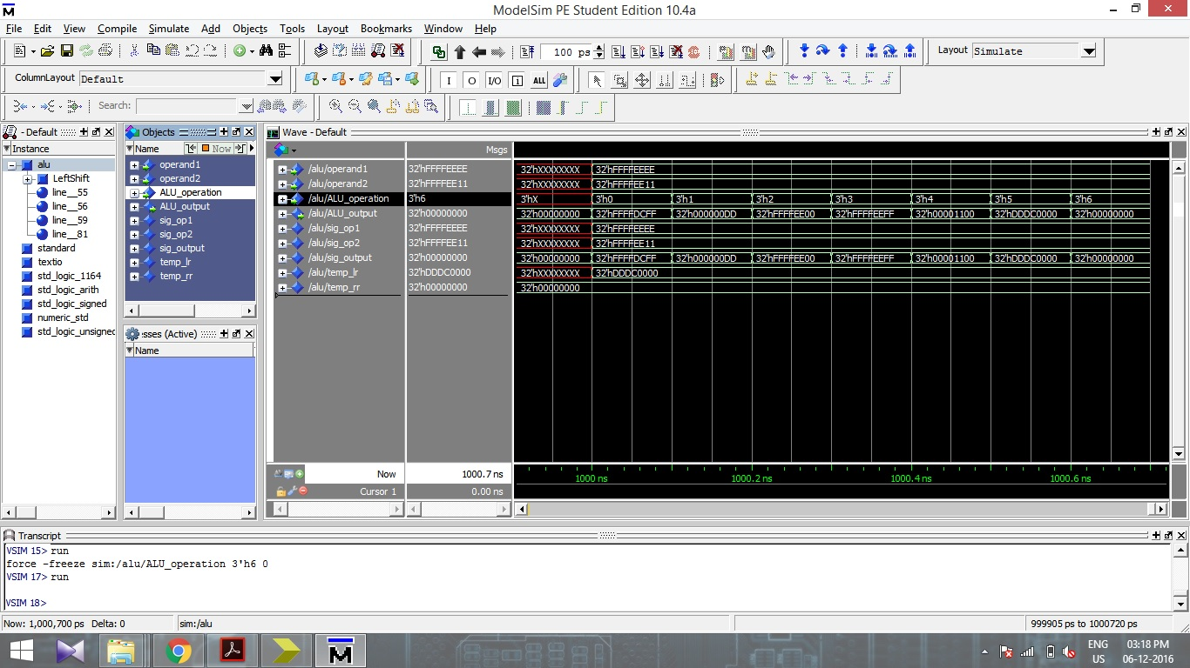

Functional Simulation 1 of ALU unit

1. Test case 2:

Operand 1 : FFEE1234

Operand 2 : FFFF1111

ALU_operation : 0 ALU_output : FFED2345

ALU_operation : 1 ALU_output : FFEF0123

ALU_operation : 2 ALU_output : FFEE1010

ALU_operation : 3 ALU_output : FFFF1335

ALU_operation : 4 ALU_output : 0000ECCA

ALU_operation : 5 ALU_output : 24680000

ALU_operation : 6 ALU_output : 00000000

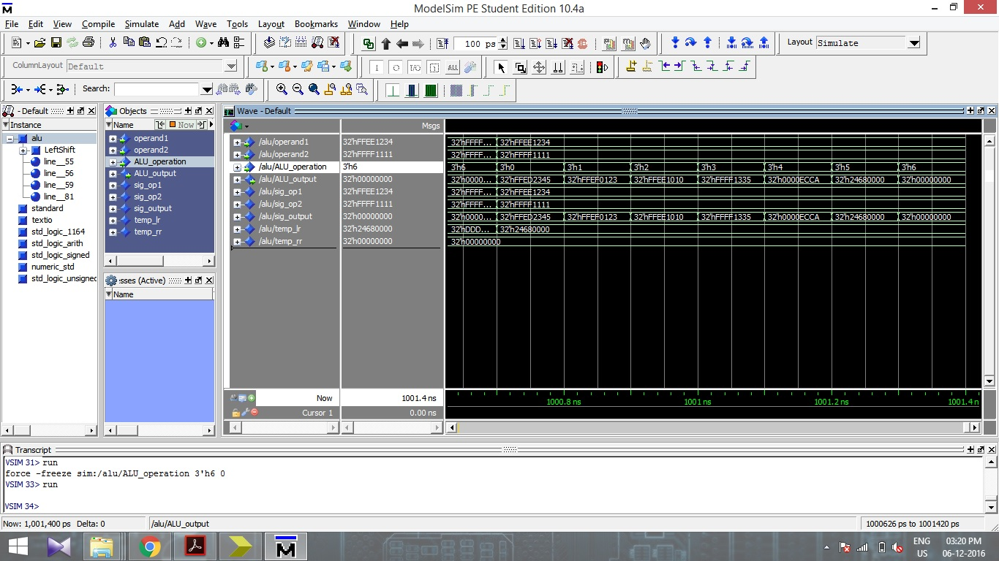

Functional Simulation 2 of ALU unit

1. Test case 3:

Operand 1 : EEEEFFFF

Operand 2 : 2222EEDD

ALU_operation : 0 ALU_output : 1111EEDC

ALU_operation : 1 ALU_output : CCCC1122

ALU_operation : 2 ALU_output : 2222EEDD

ALU_operation : 3 ALU_output : EEEEFFFF

ALU_operation : 4 ALU_output : 11110000

ALU_operation : 5 ALU_output : 00000000

ALU_operation : 6 ALU_output : 00000000

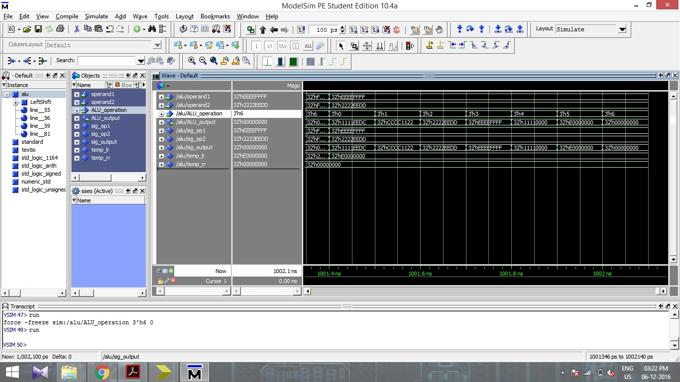

Functional Simulation 3 of ALU unit

**Timing simulation of ALU:**

The timing simulations are carried for the same inputs for which Functional simulations were carried out. The inputs (operand values) and the respective simulation screen shots are shown below.

1. Test case 1:

Operand 1 : FFFFEEEE

Operand 2 : FFFFEE11

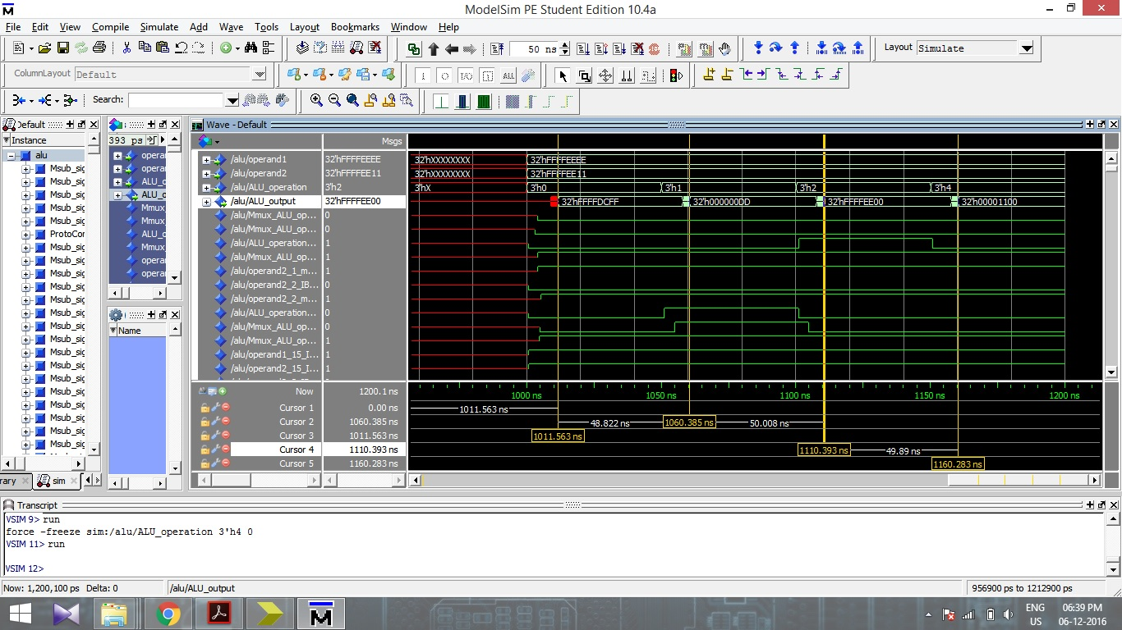

Timing Simulation 1 of ALU unit

1. Test case 2:

Operand 1 : FFEE1234

Operand 2 : FFFF1111

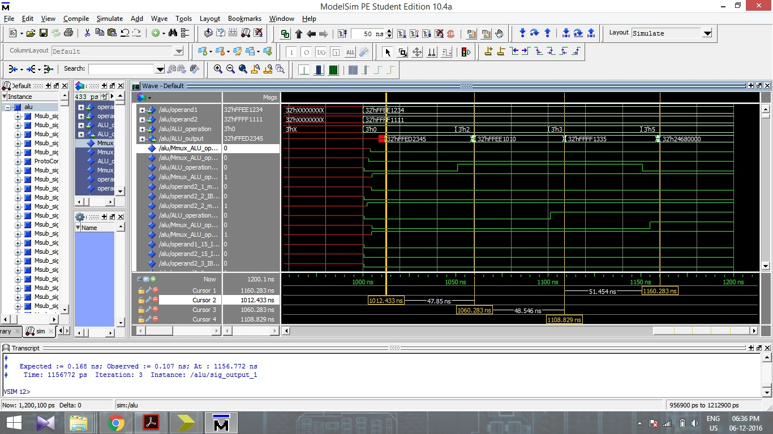

Timing Simulation 2 of ALU unit

1. Test case 3:

Operand 1 : FFEE1234

Operand 2 : FFFF1111

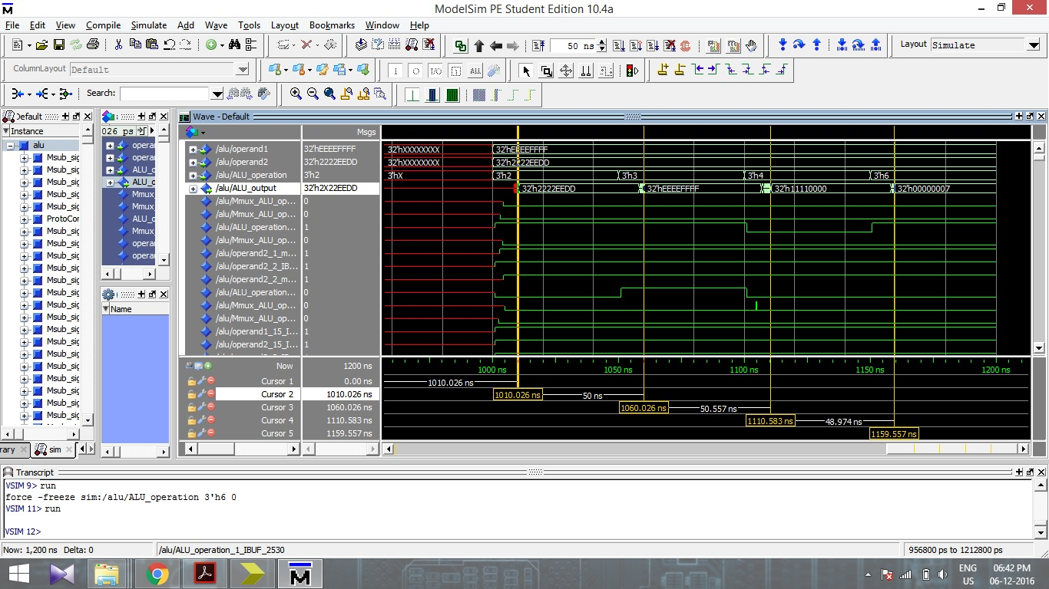

Timing Simulation 3 of ALU unit

**Decoder Unit:**

The Decoder unit was designed and the functional and timing simulations were carried out for random values of opcode, func_code and comparator. The results are shown in the screen shots below.

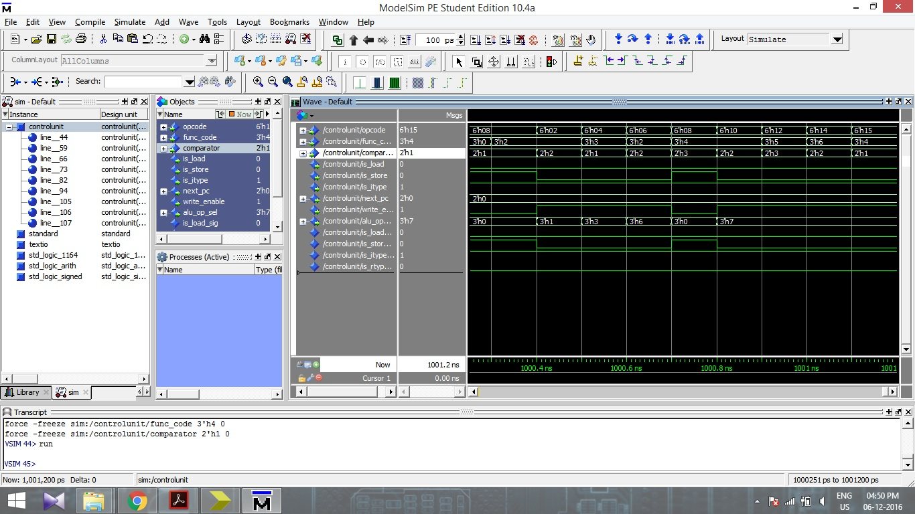

Functional Simulation of Decoder unit

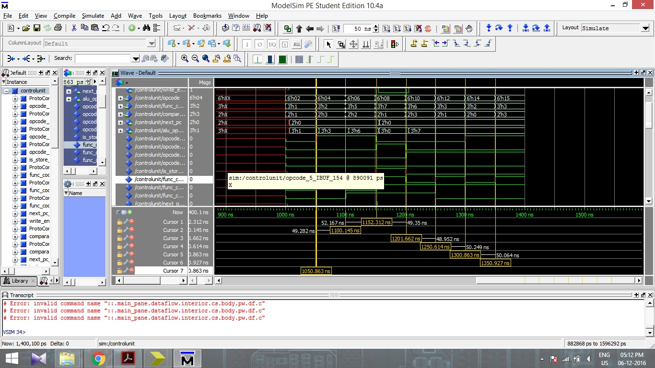

Timing Simulation 1 of Decoder unit

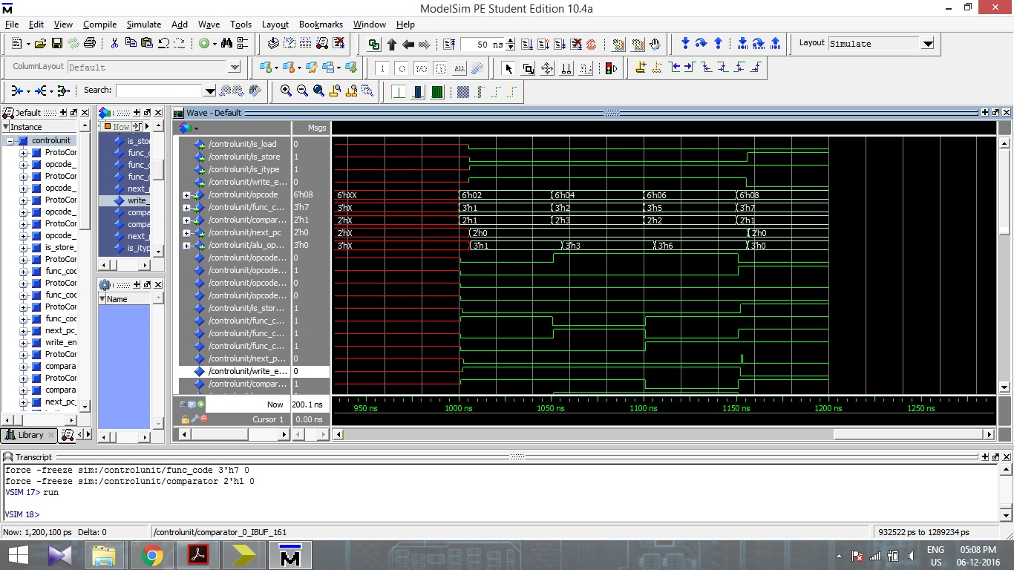

Timing Simulation 2 of Decoder unit

**32 bit Adder**

The 32 bit adder is designed and the basic components used for adder includes NOT gate, AND gate and Or gate, which combines to form Half adder and Full adder, which further combines to form a complete 32 bit adder. Functional simulation and timing simulations are carried out and the screen shots were captured for some values.

**Functional Simulation:**

1. Test case 1:

Inputs : op_1 = AABBCCDD

op_2 = 11FF2233

Outputs : sum_out = BCBAEF10

carry = 0

1. Test case 2:

Inputs : op_1 = FFFFEE22

op_2 = AAAA22FF

Outputs : sum_out = AAAA1121

carry = 1

1. Test case 1:

Inputs : op_1 = DDFF223D

op_2 = CCBBDD3D

Outputs : sum_out = AABAFF7A

carry = 1

1. Test case 1:

Inputs : op_1 = FFEE22DD

op_2 = 44FFDD11

Outputs : sum_out = 44EDFFEE

carry = 1

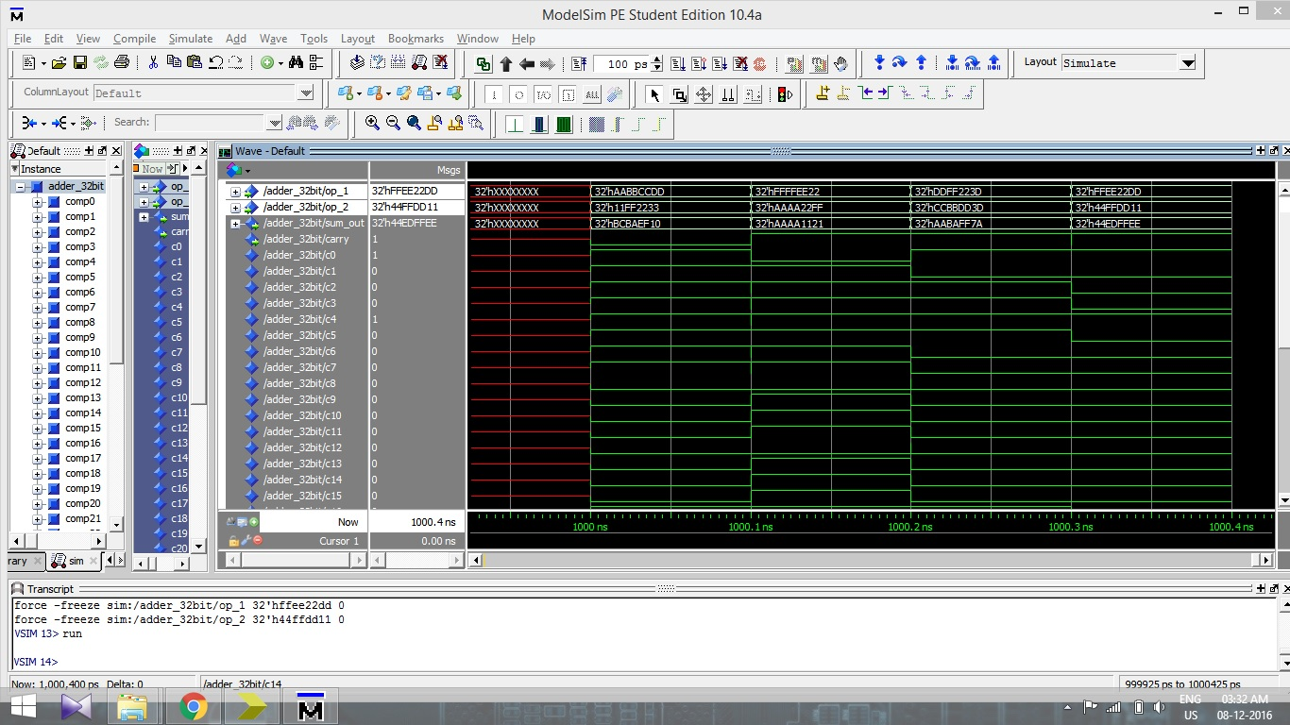

Functional Simulation of 32 bit Adder

**Timing Simulation:**

For timing simulations, same values were used as the one used for Functional simulations. We can see the same outputs and same values for the carry bits as in the functional simulations, but with a delay as shown with the horizontal bars. The screenshot of the timing simulation is shown below.

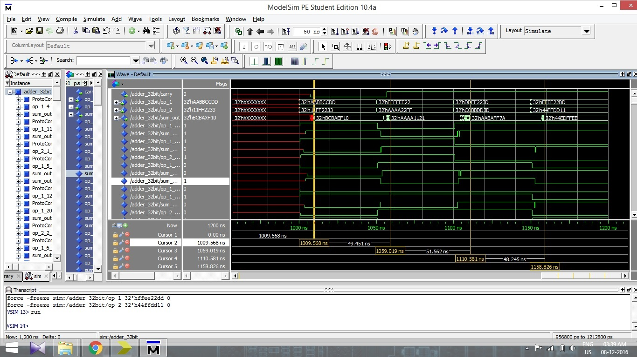

Timing Simulation of 32 bit Adder

**Comparator:**

In the comparator, the two inputs are given as input1 and input2. If the reset bit is active high or ‘1’, then the output becomes ‘0’. Else if the reset bit it is active low or ‘0’, and if both the inputs are same, the output bit shows the value ‘1’, else if input1 is greater than input2, output bit shows the value ‘2’ or if the input1 is less than input2, the output bit shows the value ‘3’.

The functional and timing simulations are carried out for the above logic, and two test cases are implemented to prove the logic.

1. Test case 1:

Input1 = FFEE2211

Input2 = FFEE2200

rst = 0

Output = 2

Input1 = FFEE2211

Input2 = FFEE2244

rst = 0

Output = 3

Input1 = FFEE2211

Input2 = FFEE2211

rst = 0

Output = 1

Input1 = FFEE2211

Input2 = FFEE2211

rst = 1

Output = 0

1. Test case 2:

Input1 = BBCC1234

Input2 = BBCC4060

rst = 0

Output = 3

Input1 = BBCC1234

Input2 = BBCC0040

rst = 0

Output = 2

Input1 = BBCC1234

Input2 = BBCC1234

rst = 0

Output = 1

Input1 = BBCC1234

Input2 = BBCC1234

rst = 1

Output = 0

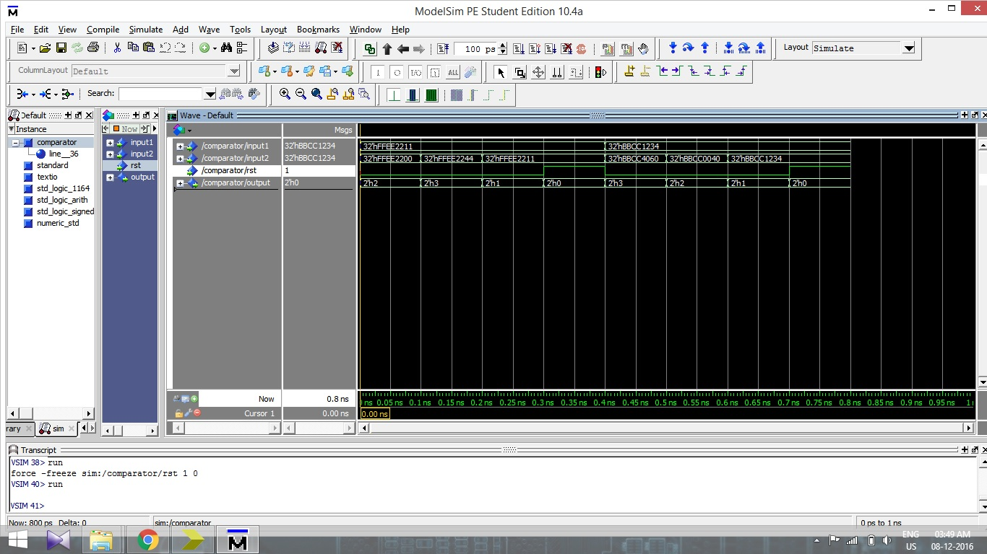

Functional Simulation of Comparator

The above figure shows the functional simulation of a Comparator. The inputs and test cases as described above are taken for simulation. The same values are used for timing simulation also. Note the delays in timing simulation screen shot below. The delays are shown by multiple horizontal bars.

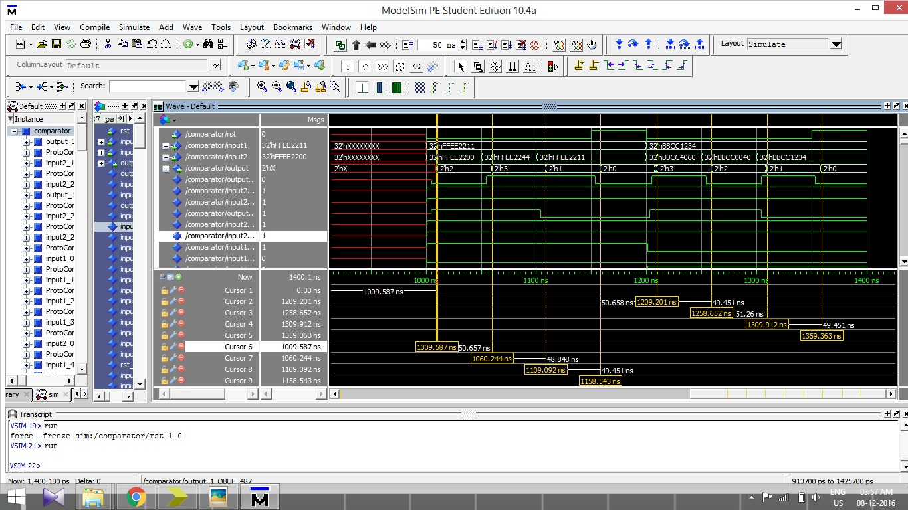

Timing Simulation of Comparator

**Left and Right Shift:**

For left and right shifts, there are 2 inputs. One of the inputs (x) is to be shifted by number of bits that is obtained by certain operation on input 2 (I). The input 2 is converted from hexadecimal to decimal, and then divided by 32. The remainder is equal to the bits to be shifted for input 1. The reason behind the division by 32 is that the rotation does not exceeds 32 bits.

**Left Shift:**

1. Test case 1:

Input 1 = FFFFEEEE

Input 2 = FFEE1111

Output = DDDC0000 (Output left shifted by 17 bits)

1. Test case 2:

Input 1 = 1122FFFF

Input 2 = 11112222

Output = 448BFFFC (Output left shifted by 2 bits)

1. Test case 3:

Input 1 = 11223344

Input 2 = FFDDEEEE

Output = 8CD10000 (Output left shifted by 14 bits)

1. Test case 4:

Input 1 = AABBCCDD

Input 2 = 11112244

Output = ABBCCDD0 (Output left shifted by 4 bits)

1. Test case 5:

Input 1 = 2244BBCC

Input 2 = 999988DD

Output = 80000000 (Output left shifted by 29 bits)

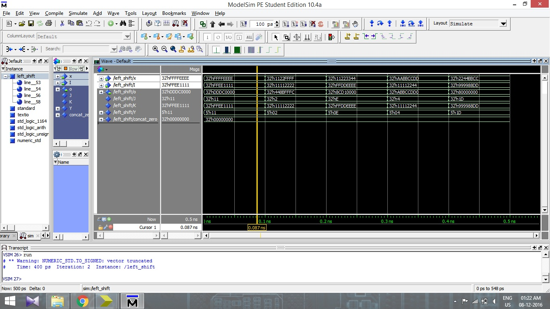

Functional Simulation for Left shift

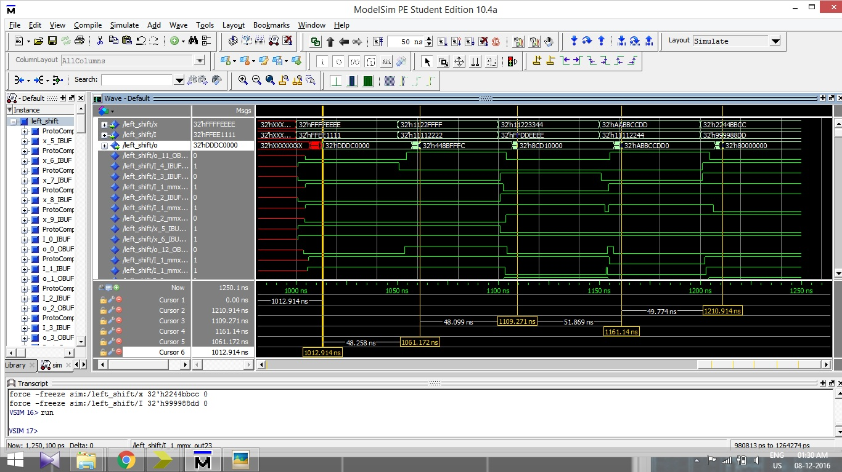

Timing Simulation for Left shift

**Right Shift:**

1. Test case 1:

Input 1 = FFFFEEEE

Input 2 = 00007FFF

Output = DDDC0000 (Output right shifted by 17 bits)

1. Test case 2:

Input 1 = 1122FFFF

Input 2 = 11112222

Output = 0448BFFF (Output right shifted by 2 bits)

1. Test case 3:

Input 1 = 11223344

Input 2 = FFDDEEEE

Output = 00004488 (Output right shifted by 14 bits)

1. Test case 4:

Input 1 = AABBCCDD

Input 2 = 11112244

Output = 0AABBCCD (Output right shifted by 4 bits)

1. Test case 5:

Input 1 = 2244BBCC

Input 2 = 999988DD

Output = 00000001 (Output right shifted by 29 bits)

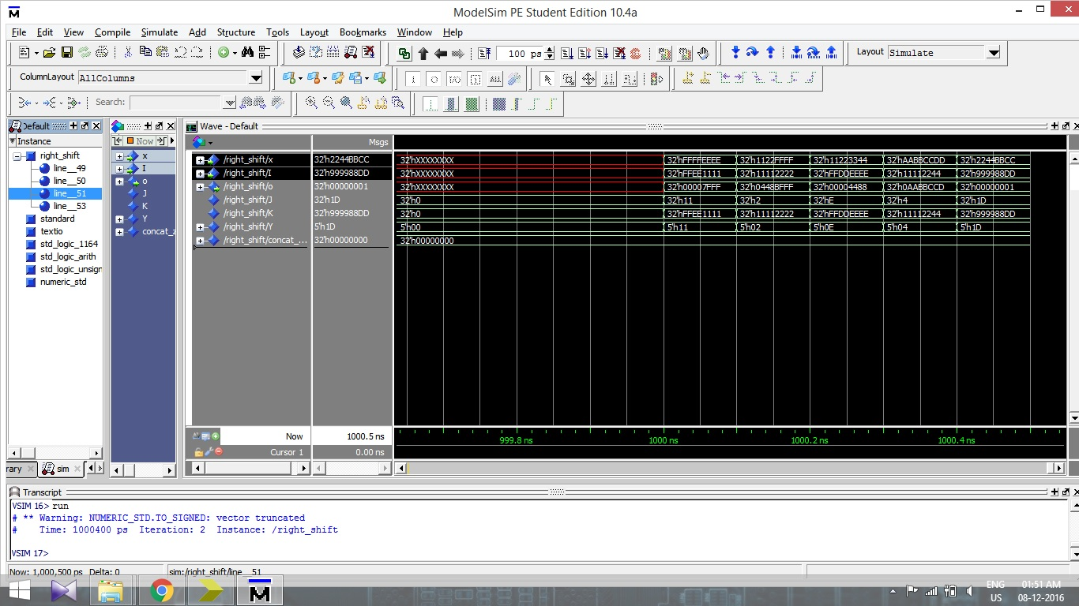

Functional Simulation of Right shift

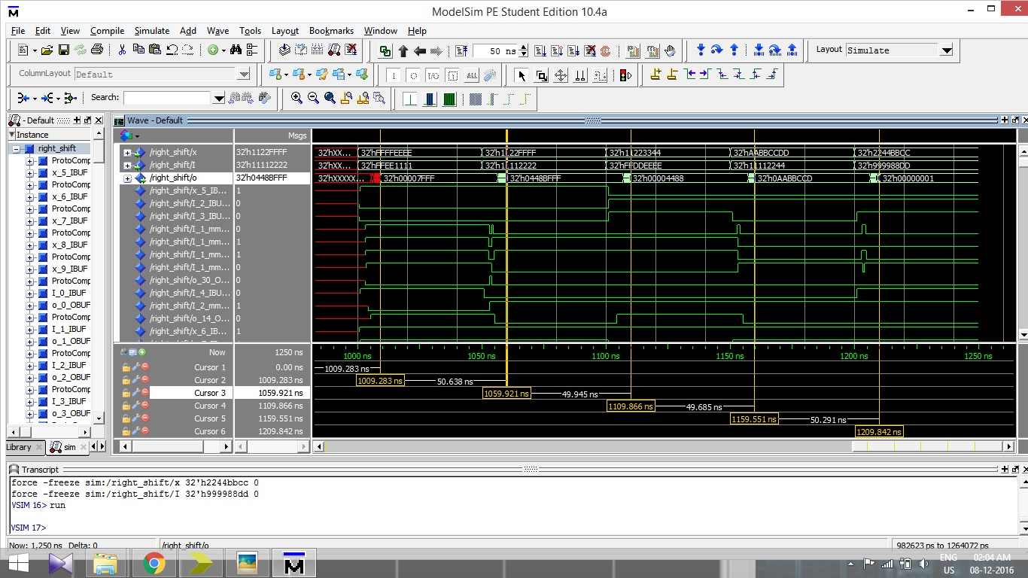

Timing Simulation of Right shift

**MUX 5 bit 2x1:**

A 5 bit MUX is designed with 2x1 selection. Two 5 bits inputs (inp_0 and inp_1) are given, and a control input is to be selected between active high or ‘1’ and active low or ‘0’. If the control is set as active low or ‘0’, the output shows the exact same value as inp_0, otherwise, if the control is ‘1’, then the output shows exactly same as inp_1.

1. Test case 1:

Inp_0 = h`10

Inp_1 = h`1B

Ctrl = 0 Ctrl = 1

Output = h`10 Ctrl = h`1B

1. Test case 1:

Inp_0 = h`07

Inp_1 = h`1F

Ctrl = 0 Ctrl = 1

Output = h`07 Output = h`1F

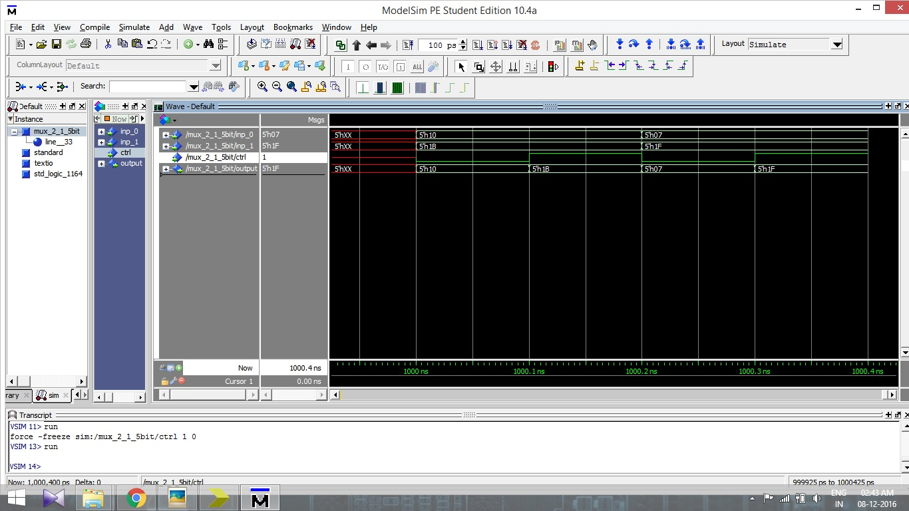

Functional Simulation of MUX 5 bit with 2x1 selection

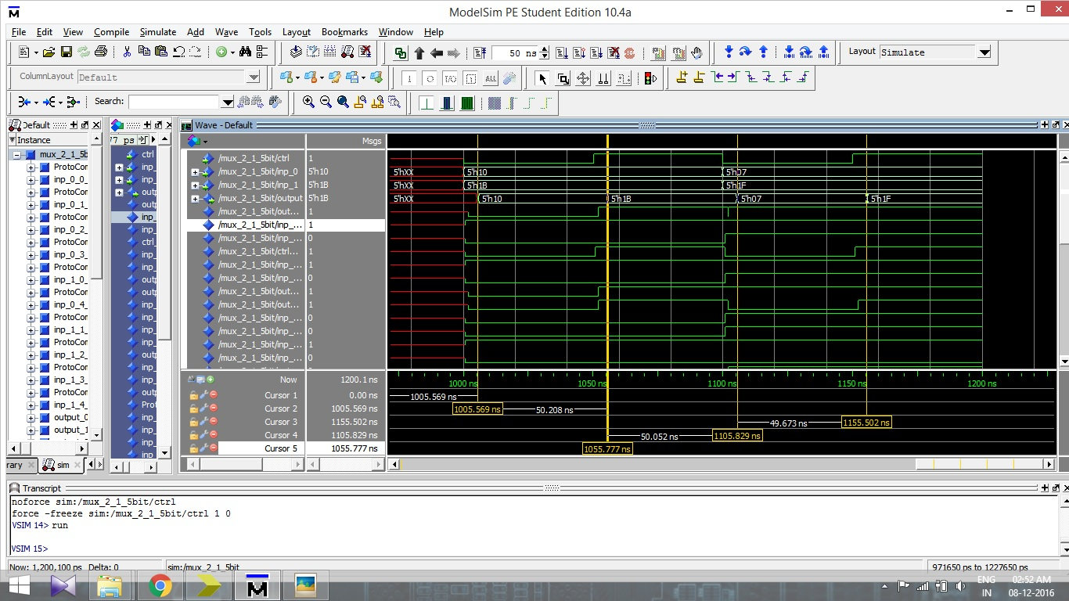

Timing Simulation of MUX 5 bit with 2x1 selection

**MUX 32 bit 2x1:**

A similar MUX for 32 bits input is designed with 2x1 selection. If the control input is active low or ‘0’, the output becomes equal to inp_0, otherwise, if control input is active high or ‘1’, the output becomes equal to inp_1.

1. Test case 1:

Inp_0 = FFFFEEEE

Inp_1 = 11223344

Ctrl = 0 Ctrl = 1

Output = FFFFEEEE Output = 11223344

1. Test case 1:

Inp_0 = AABBCCDD

Inp_1 = FFEE2222

Ctrl = 0 Ctrl = 1

Output = AABBCCDD Output = FFEE2222

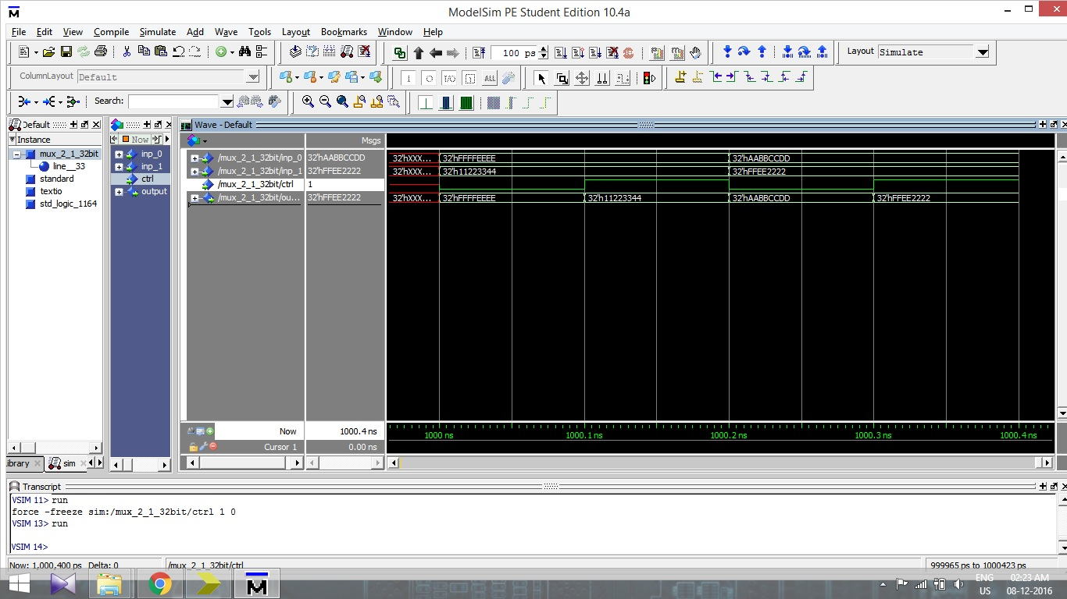

Functional Simulation of MUX 32 bits with 2x1 selection

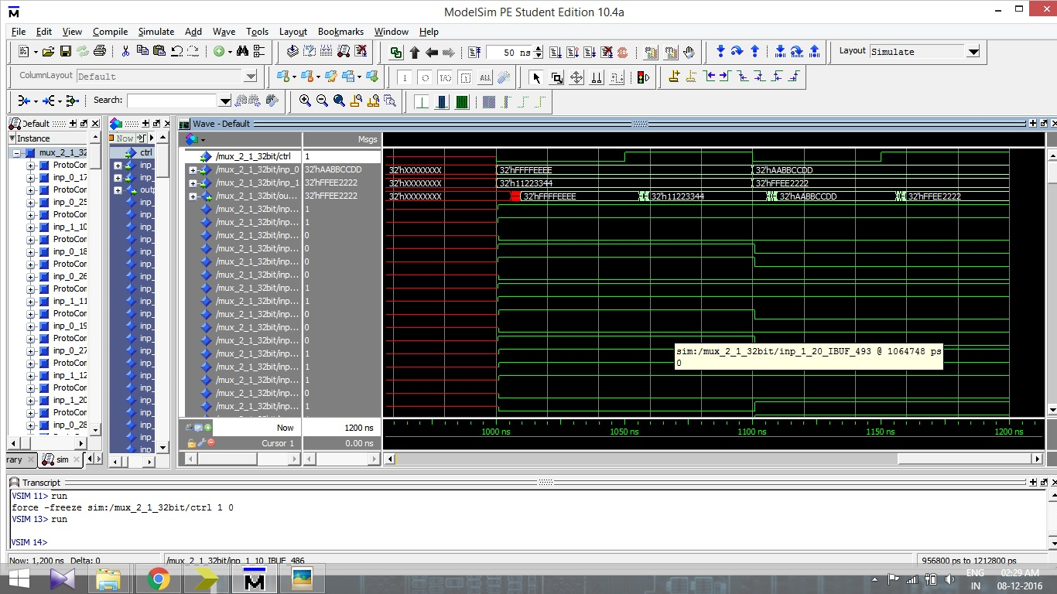

Timing Simulation of MUX 32 bits with 2x1 selection

**MUX 32 bit 4x1:**

One more 32 bit MUX is designed with 4x1 selection. Here, four different inputs are given, and the output is equal to one of the inputs depending on the control input. The timing and functional simulations are carried out for two test cases as shown below.

1. Test case 1:

Inp_0 = 11ABCD11

Inp_1 = 22ABCD22

Inp_2 = 33ABCD33

Inp_3 = 44ABCD44

Reset = 0

Ctrl = 0 output = 11ABCD11

Ctrl = 1 output = 22ABCD22

Ctrl = 2 output = 33ABCD33

Ctrl = 3 output = 44ABCD44

Reset = 1 output = 00000000

1. Test case 1:

Inp_0 = FFEE0000

Inp_1 = FFEE1111

Inp_2 = FFEE2222

Inp_3 = FFEE3333

Reset = 0

Ctrl = 0 output = FFEE0000

Ctrl = 1 output = FFEE1111

Ctrl = 2 output = FFEE2222

Ctrl = 3 output = FFEE3333

Reset = 1 output = 00000000

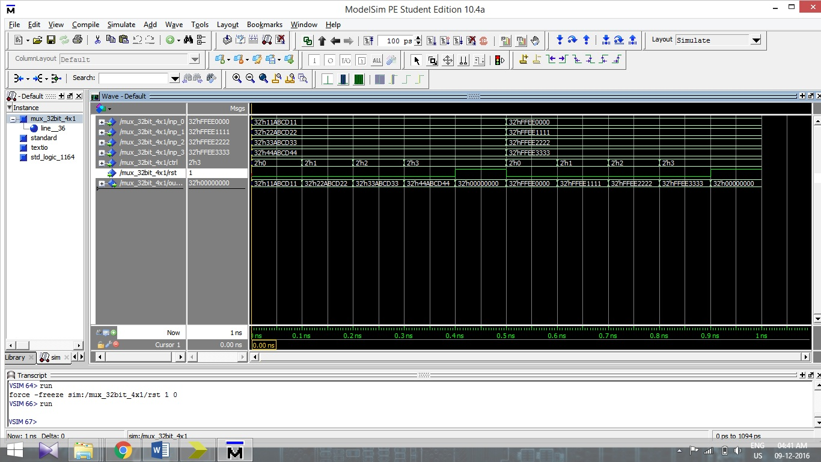

Functional simulation for MUX 32 bit with 4x1 selection

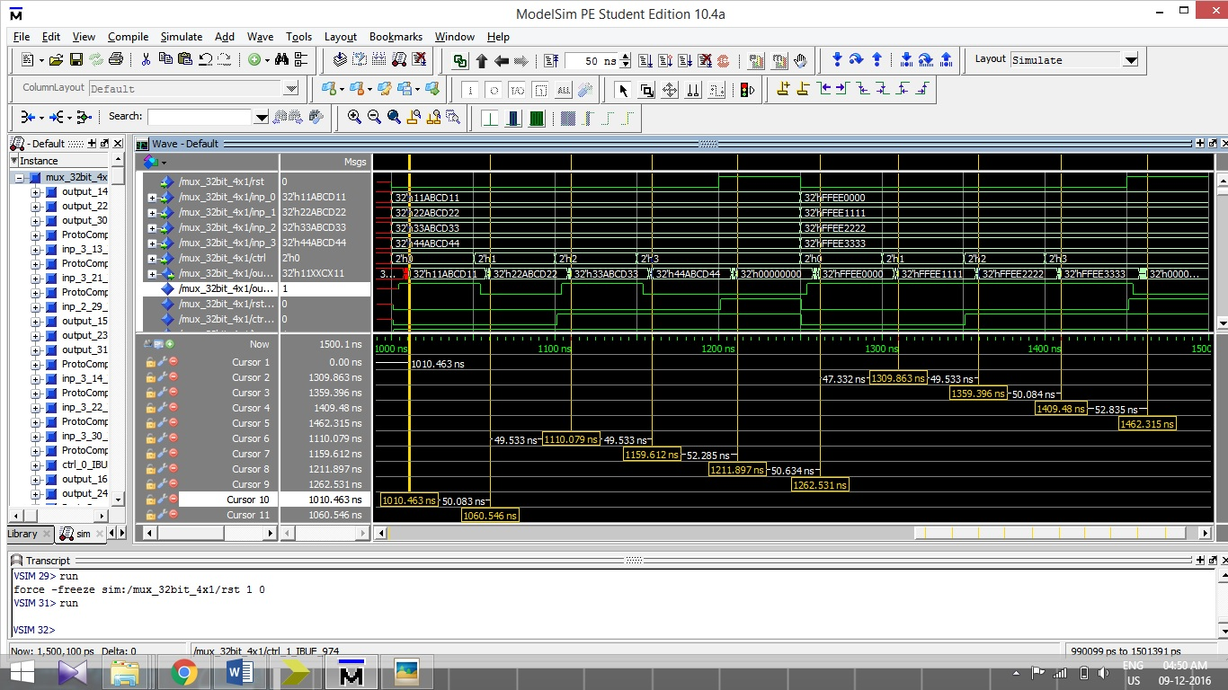

Timing simulation for MUX 32 bit with 4x1 selection

**Sign Extend:**

Sign_extend is the component that is designed specially. It accepts one input, 16 bits wide, and gives one output. The output is 32 bits wide and the output depends on the MSB of 16 bits wide input. If the MSB of the input is ‘1’, then the output is created with all 16 MSBs equal to ‘1’, or ‘FFFF’ in hexadecimal form. If the MSB of the input is ‘0’, then the output will be same as input, with 16 MSBs equal to ‘0’. The simulations, both functional and timing are carried out, with three different inputs as follows.

1. Test case 1:

Input = h`ABCD (1010101111001101)

Output = h`FFFFABCD

Here, the MSB of the 16 bit input is ‘1’. So, the MSBs of the output becomes ‘1’ and the output thus becomes “FFFFABCD” in hexadecimal.

1. Test case 2:

Input = h`4321 (0100001100100001)

Output = h`00004321

Here, the MSB of the 16 bit input is ‘0’. So, the MSBs of the output becomes ‘0’ and the output thus becomes “00004321” in hexadecimal. Note that the output is same as the input, but resembled in 32 bits form.

1. Test case 3:

Input = h`C001 (1100000000000001)

Output = h`FFFFC001

Here, the MSB of the 16 bit input is ‘1’. So, the MSBs of the output becomes ‘1’ and the output thus becomes “FFFFC001” in hexadecimal.

The functional and the timing simulation are carried out and the screen shots are shown below. The results of both the simulations are same, except in the timing simulation, the results are shown with significant delays. The delays are shown with the help of horizontal bars.

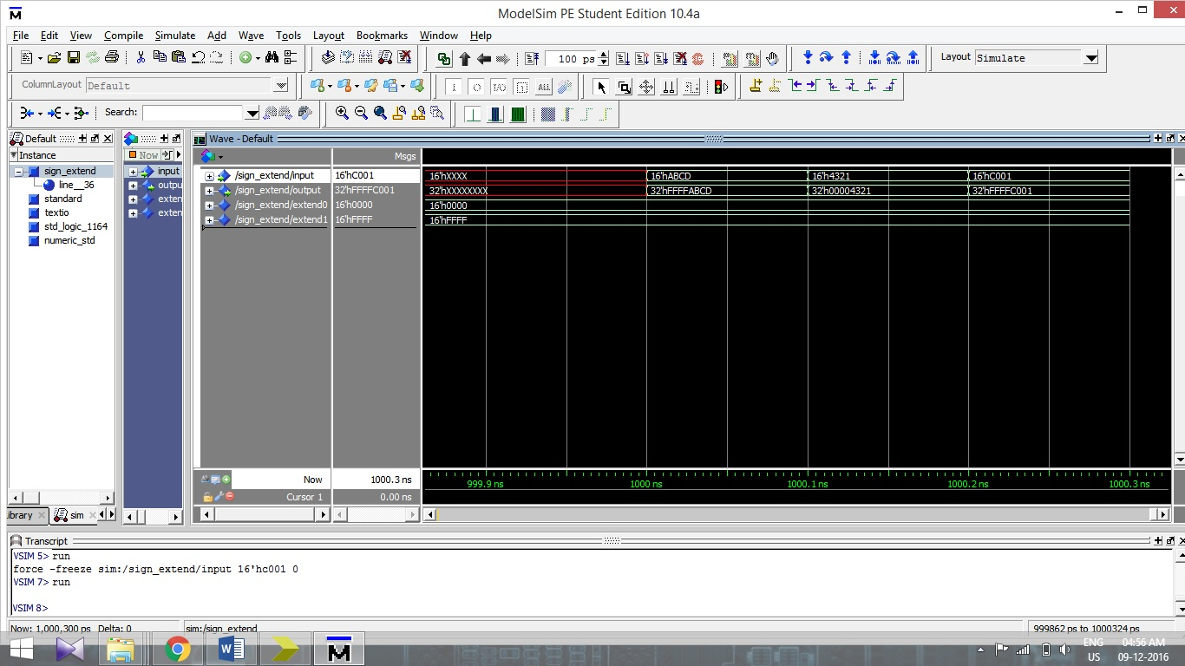

Functional simulation for sign_extend

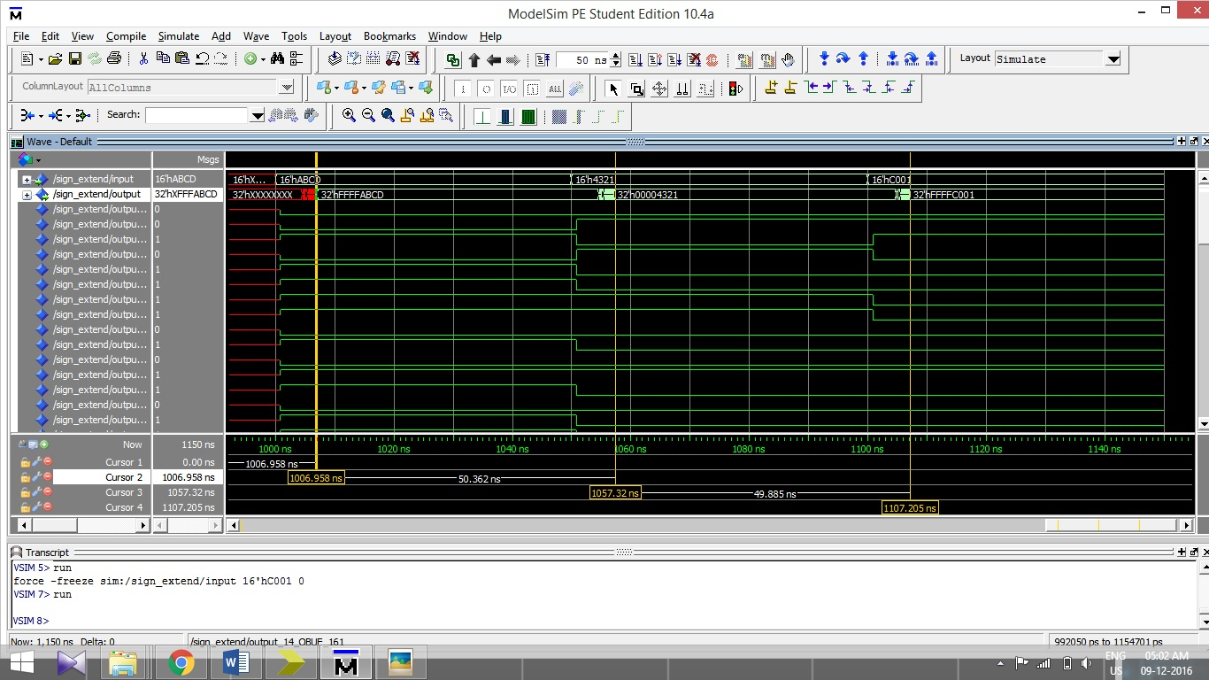

Timing simulation for sign_extend

**Program Counter:**

In the Program Counter, the input_pc is 32 bits wide, and the output_pc is also 32 bits wide. With each rising edge of the clock, the output_pc shows the value that is equal to the input_pc unless the reset bit (rst) is not equal to ‘1’. Whenever the rst bit is set to active high or ‘1’, then the value in output_pc is readjust to ‘00000000’. The simulation of Program counter is done and the screen shot is shown below.

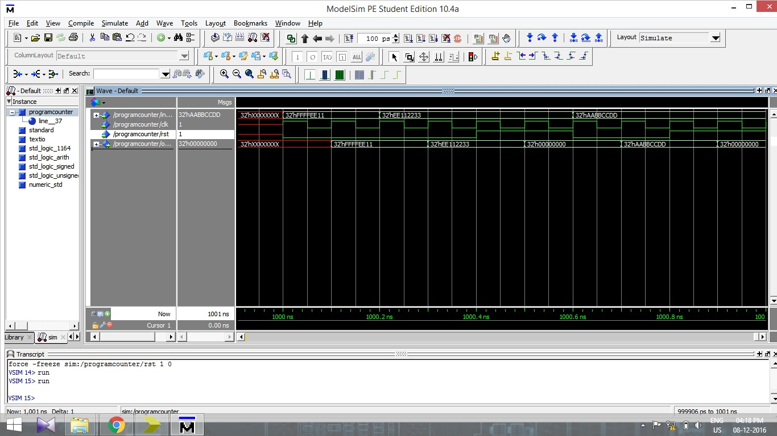

Simulation of Program Counter with 3 different values. Note that the output shows exact value as the input unless rst bit is not ‘1’. With rst bit becoming ‘1’, the output_pc becomes ‘00000000’.

**Register File:**

The register file is designed with two read addresses (read_address_rs and read_address_rt) and a write address as inputs. All the three addresses are 5 bits wide. Then, the data to be written, or write_data, which is 32 bits wide, is to be entered as input. This 32 bits wide data is written at the address specified by the write address. Now, the output can be read by changing the read addresses in the inputs. Note that the conditions are set for the data to be written. The write enabled bit should be active high or set to ‘1’ to make the writing operation. Also note that all the operations are being done with the positive cycle of the clock.

**Functional Simulation:**

For the simulation, the read_address_rs and read_address_rt were set to h`10 and h`11 respectively and the write_address was set to h`12. The write_data was set to h`FFFFEEEE. Thus, with the positive cycle of the clock, the data, h`FFFFEEEE would be written on the address h`12. Now, for the next cycle, the read_address_rs is set to h`12 and the write_address is set to h`13. So the output_data_rs will show the data h`FFFFEEEE written on the address h`12 and the same data will be written on the new address h`13. Further, the read_address_rt is set to h`13 and the data h`FFFFEEEE is to be written on the new address h`14. So the output_data_rt will show the data h`FFFFEEEE and the new data h`FFFF1111 is written on the new address h`14. For the next cycle, the read_address_rs is set to h`14, and the write_address is set to h`15. Thus, the output_data_rs will be equal to the new data h`FFFF1111 and data is written on the address h`15. Finally, the read_address_rt is set to h`15 and for the next cycle, the output_data_rt will resemble the data h`FFFF1111 from the address h`15.

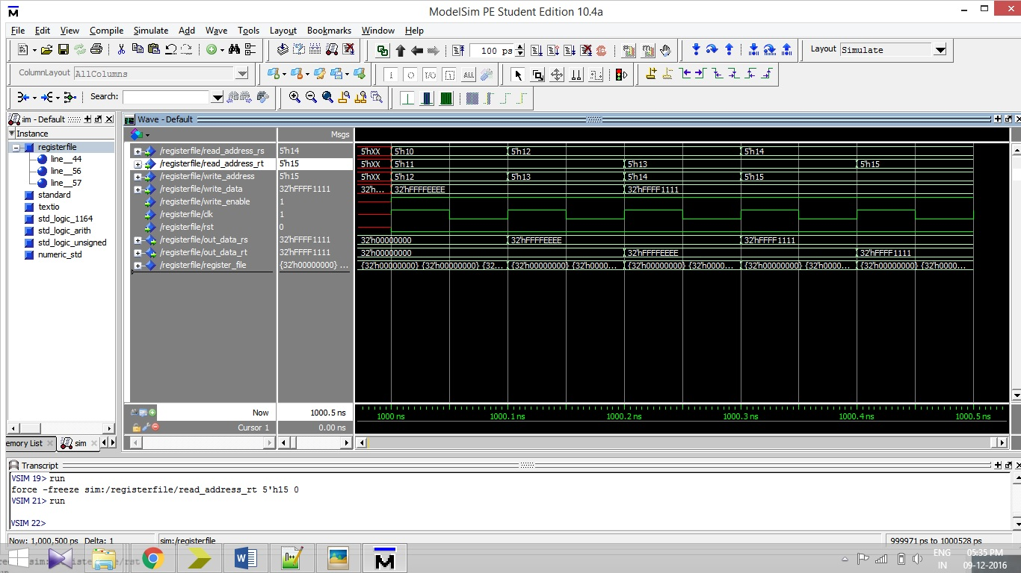

Functional simulation for the Register File. Note the changes in the output data, when the input_read_addresses and the write_address are changed.